Chapter 6, Problem 28.

Obtain the equivalent capacitance of the network shown in Fig. 6.58.

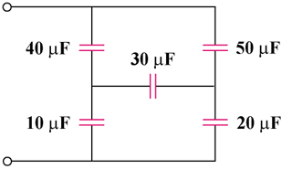

Figure 6.58
For Prob. 6.28.

